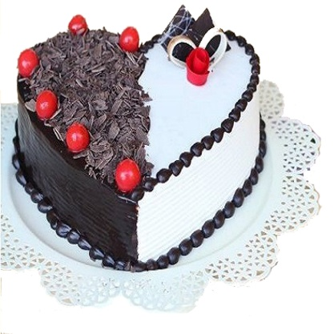

Black forest

1kg – 900

2kg – 1780

3kg – 2650


Blueberry Flavor
1kg – 850
2kg – 1750
3kg – 2600
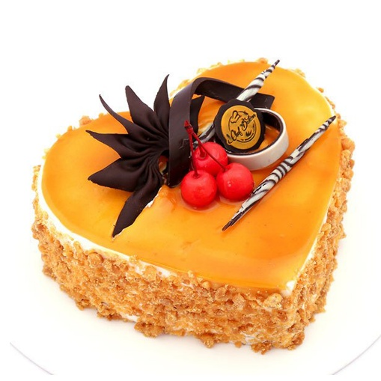

Butterscotch
1kg – 950
2kg – 1900
3kg – 2850


Choco Chips
1kg – 1000
2kg – 2000
3kg – 3000


Choco Vanilla Flavour
500g – 350
1kg – 680
2kg – 1350
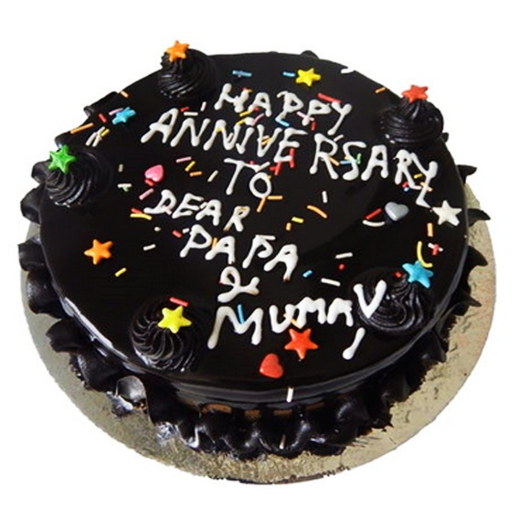

Dark Chocolate
500g – 450
1kg – 950
2kg – 1900
3kg – 2850
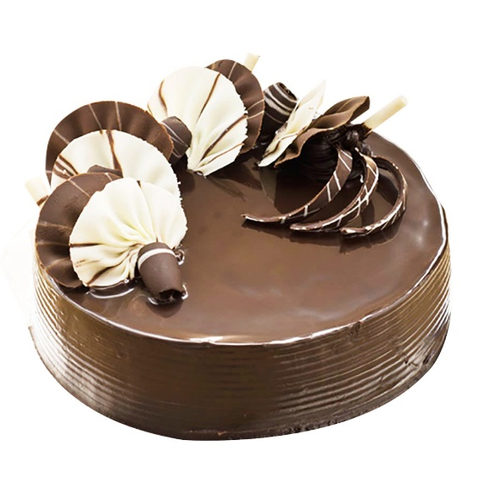

Delight Chocolate
500g – 500
1kg – 1000
2kg – 2000
3kg – 3000
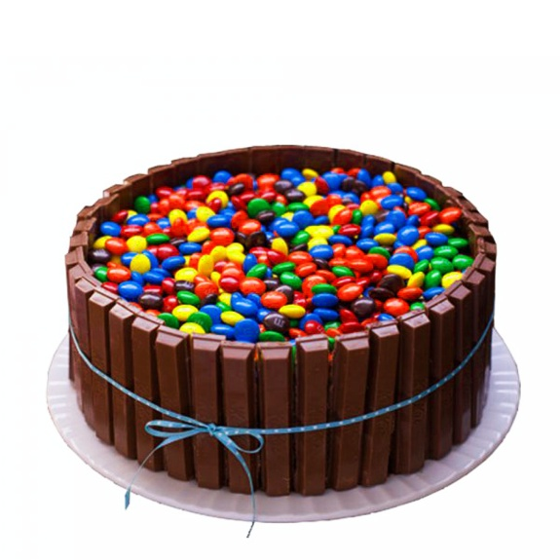

KitKat
500g – 700
1kg – 1400
2kg – 2800
3kg – 4200



Pineapple Flavor
1kg – 750
2kg – 1500
3kg – 2300

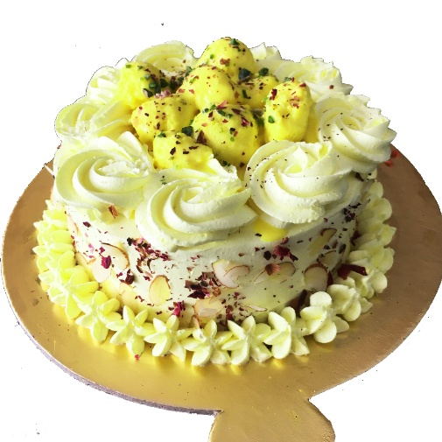

Rashmalai
500g – 500
1kg – 1000
2kg – 2000
3kg – 3000


Red Velvet
1kg – 1100
2kg – 2200
3kg – 3300


Strawberry Flavor
1kg – 800
2kg – 1650
3kg – 2450
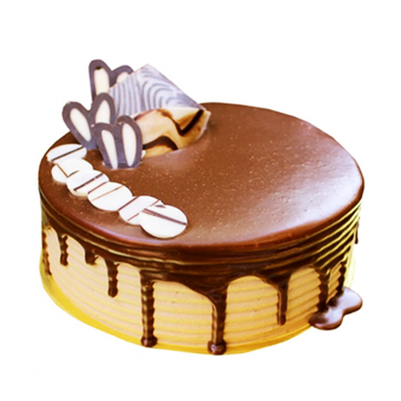

Swiss Chocolate
500g – 400
1kg – 800
2kg – 1700
3kg – 2500


White Forest
1kg – 800
2kg – 1600
3kg – 2400

