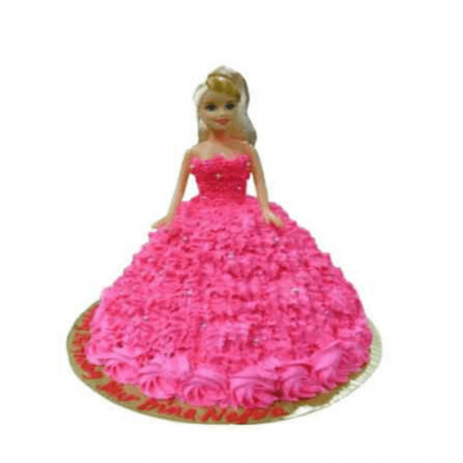

Barbie Cake ( Vanilla Flavour)
1kg – 750
2kg-1350
3kg-1980

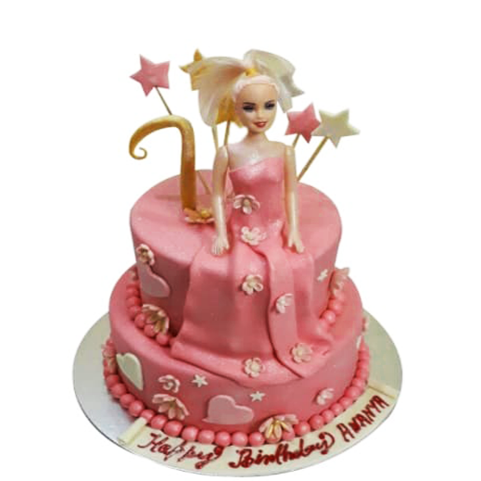

Butter Scotch
1kg –
2kg-
3kg-3400

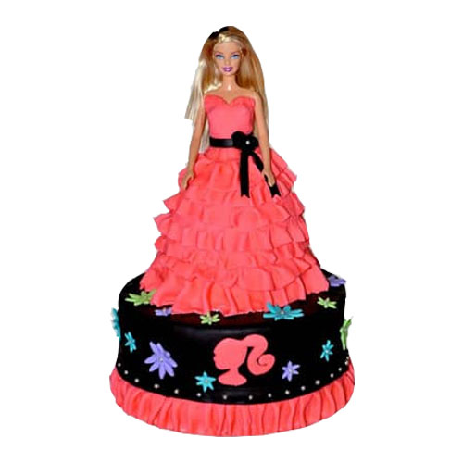

Chocolate Flavor
1kg –
2kg-
3kg- 2650
4kg- 3500

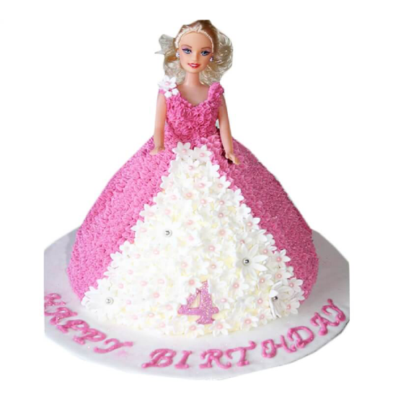

Vanilla Flavor
1kg –
2kg-1000
3kg- 1500
4kg- 2000

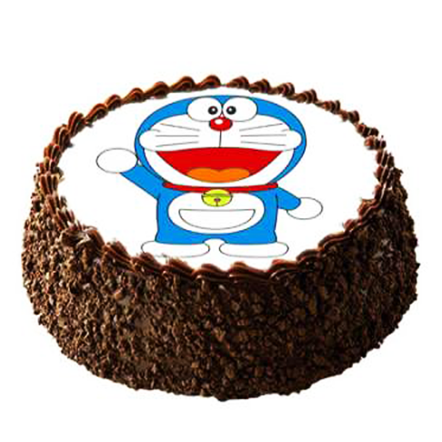

Choco Chips
2kg-1800
3kg- 2700

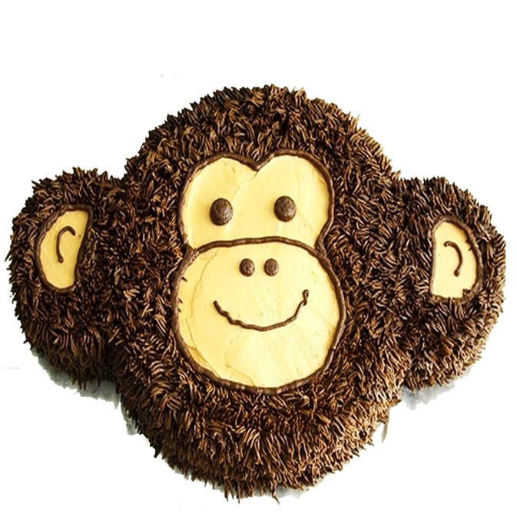

Delight Chocolate
3kg- 2900
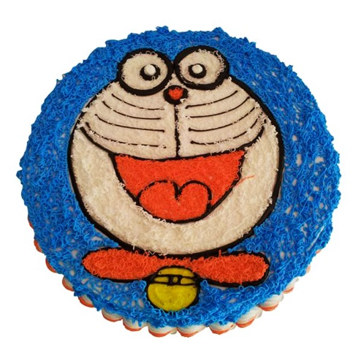

Vanilla
1kg – 750
2kg-1450
3kg- 2150
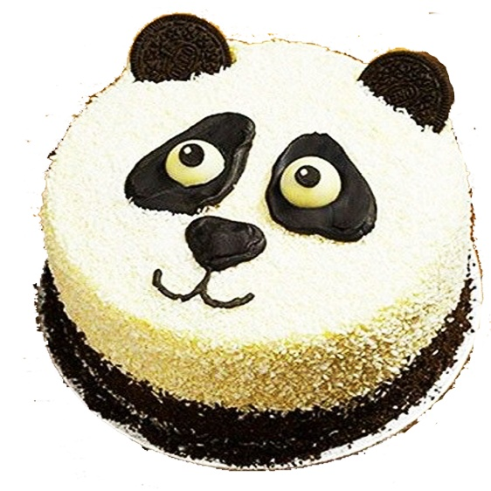

White Forest
1kg – 950
2kg-1850
3kg- 2800

