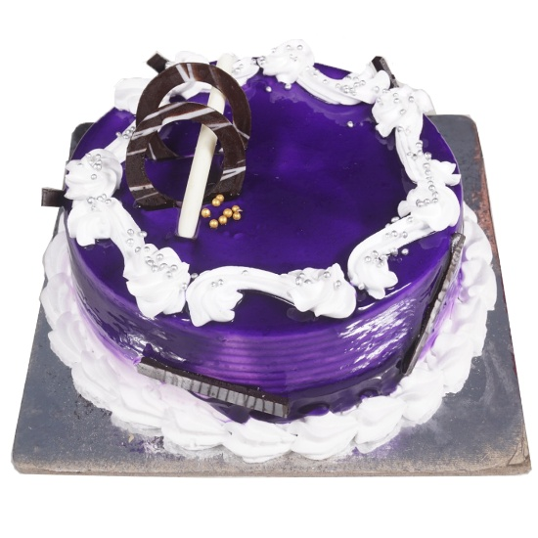
Birthday Cakes

Black Currant Flavor

500g – 350
1kg – 750
2kg – 1500
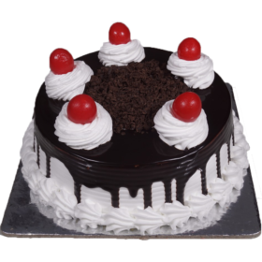

Black Forest
500g – 380
1kg – 780
2kg – 1550
3kg – 2300
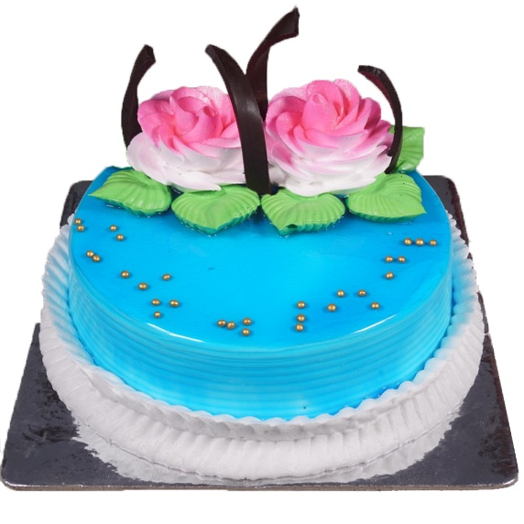

Blueberry
500g – 350
1kg – 850
2kg – 1700
3kg – 2400
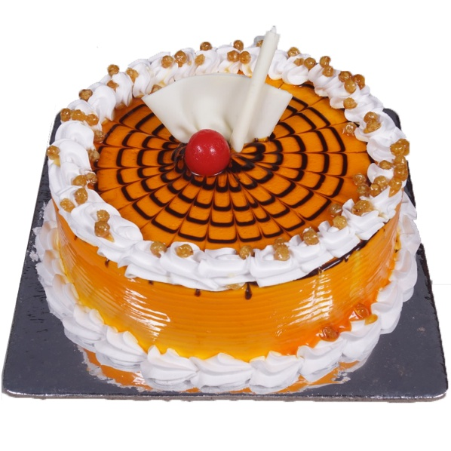

Butter Scotch
500g – 350
1kg – 750
2kg – 1500
3kg – 2250
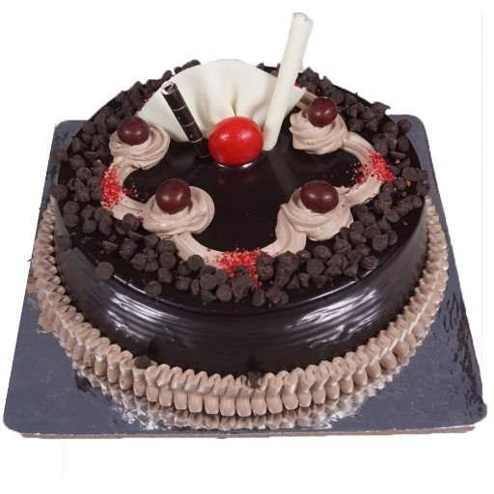

Choco Chips
500g – 380
1kg – 750
2kg – 1500
3kg – 2300
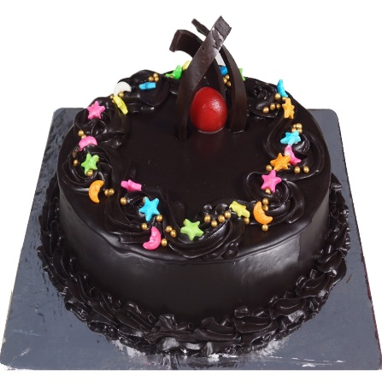

Dark Chocolate
500g – 480
1kg – 960
2kg – 1900
3kg – 2850
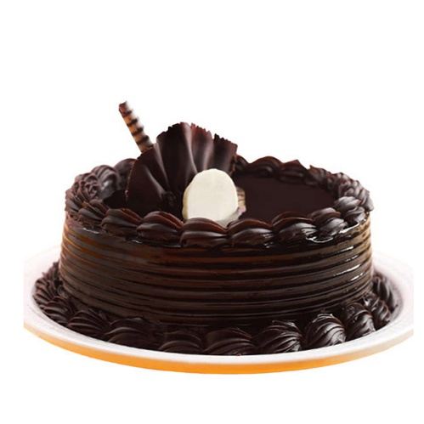

Delight Chocolate

Product Description:
Highlights:
- Cake Flavor – Chocolate
- Type of cake – Fondant
- Minimum Weight – 500 gm
- Type of Bread – Chocolate
- Type of cream – Chocolate
- Filling in Layers – cream
- Toppings – Fondant
Delivery Details
- The delicious cake is hand-delivered by our delivery boy in a good quality cardboard box.
- Candle and knife will be delivered as per the availability
Care Instructions
- Store cake in a refrigerator
- Consume cake within 24 hours
Chocolate cake prepared with the finest quality ingredients that is whipped with fresh cream for an eye-catching appearance. It is featured with mouthwatering blend of chocolate.
Ingredients Used: Â
All-purpose flour, White sugar, Baking powder, Baking soda, Salt, Milk, Vegetable oil, Chocolate extract, White sugar, Cornstarch, Whipping cream, Confectioners’ sugar.

500g – 450
1kg – 950
2kg – 1900
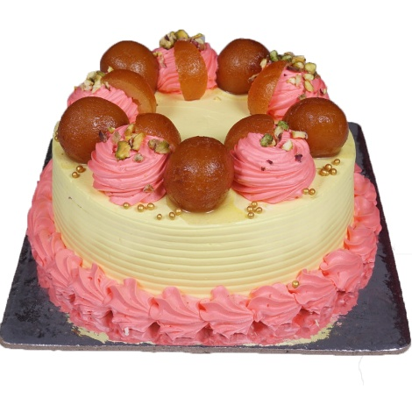

Gulab Jamun
500g – 480
1kg – 960
2kg – 1900
3kg – 2900
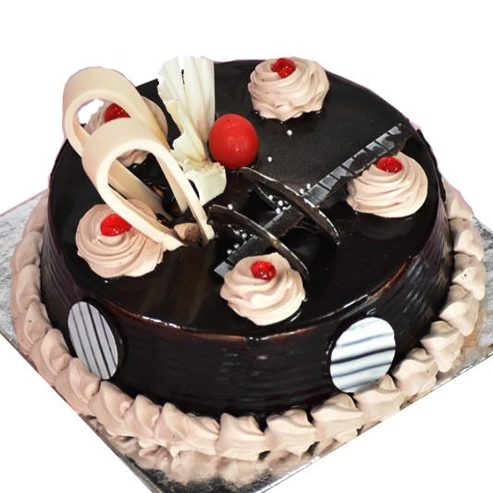

Italian Cassasta
500g – 400
1kg – 850
2kg – 1700
3kg – 2600
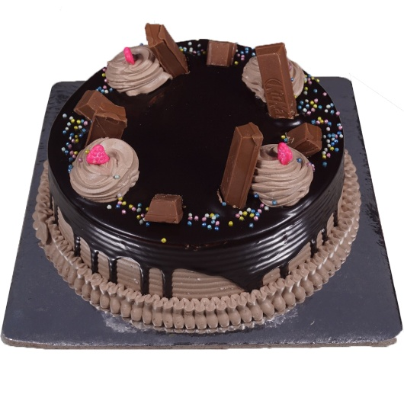

Kit Kat Chocolate
500g – 400
1kg – 850
2kg – 1700
3kg – 2600
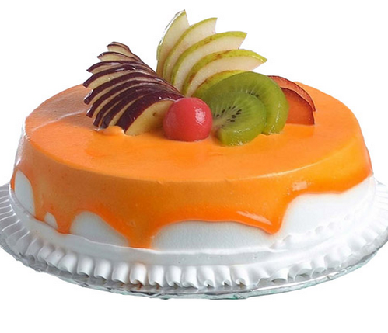

Mix Fresh Fruit
500g – 400
1kg – 900
2kg – 1800
3kg – 2700
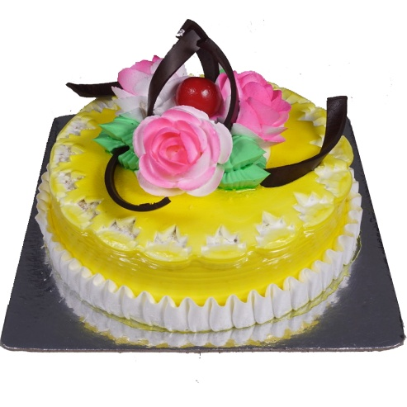

Pineapple
500g – 350
1kg – 740
2kg – 1500
Highlights:
- Cake Flavor – Pineapple
- Type of cake – Fondant
- Minimum Weight – 500 gm
- Type of Bread – Pineapple
- Type of cream – Pineapple
- Filling in Layers – cream
- Toppings – Fondant
Delivery Details
- The delicious cake is hand-delivered by our delivery boy in a good quality cardboard box.
- Candle and knife will be delivered as per the availability
Care Instructions
- Store cake in a refrigerator
- Consume cake within 24 hours
Pineapple cake prepared with the finest quality ingredients that is whipped with fresh cream for an eye-catching appearance. It is featured with mouthwatering blend of Pineapple .
Ingredients Used :Â
All-purpose flour, White sugar, Baking powder, Baking soda, Salt, Milk, Vegetable oil, Pineapple extract, White sugar, Cornstarch, Whipping cream, Confectioners’ sugar.

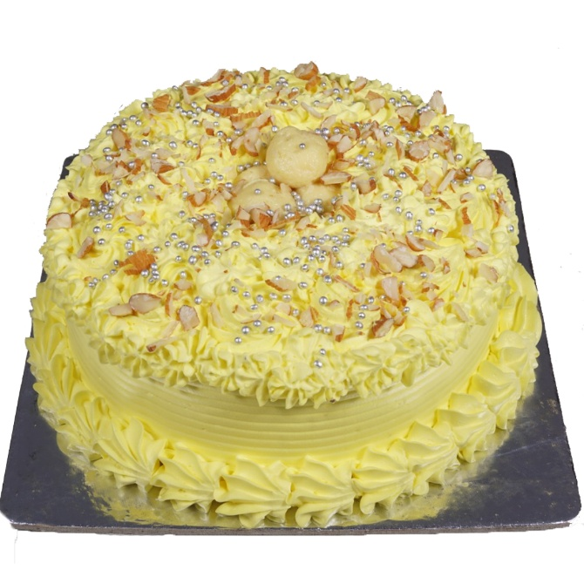

Rashmalai Cake
500g – 450
1kg – 900
2kg – 1800
3kg – 2700

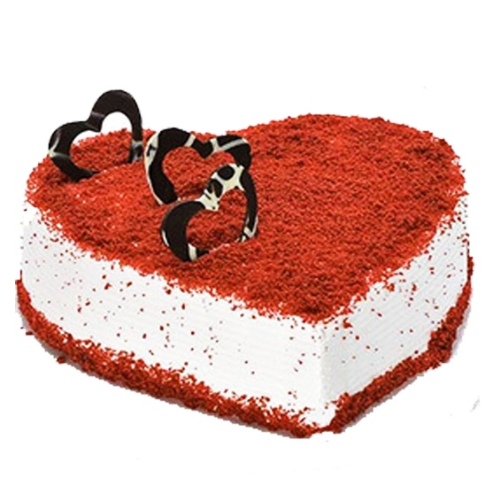

Red Velvet
1kg – 1100
2kg – 2200
3kg – 3300

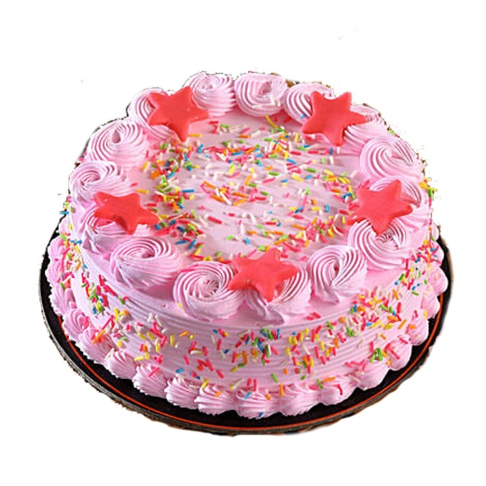

Strawberry Cake
500g – 350
1kg – 720
2kg – 1500
3kg – 2200

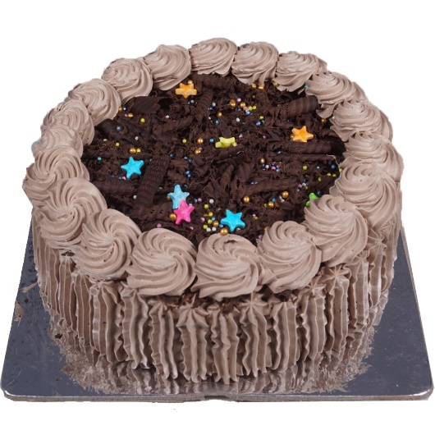

Swiss Chocolate
500g – 450
1kg – 950
2kg – 1900
3kg – 2800
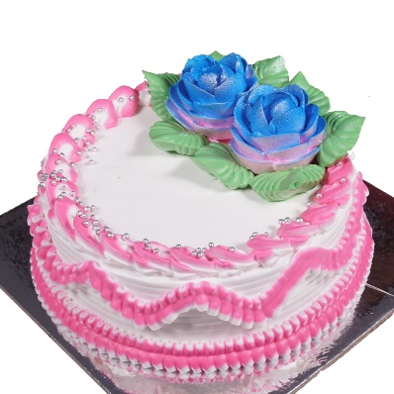

Vanilla Flavor
500g – 350
1kg – 700
2kg – 1250

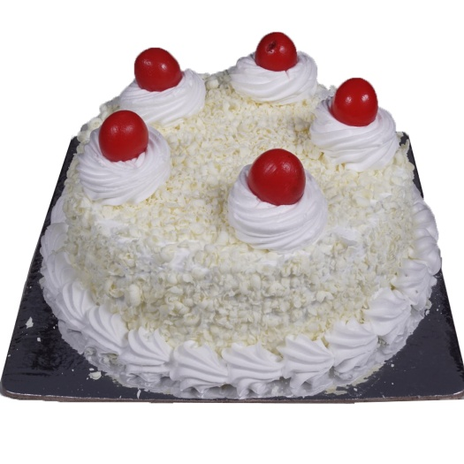

White Forest
500g – 350
1kg – 750
2kg – 1550
3kg – 2300

